
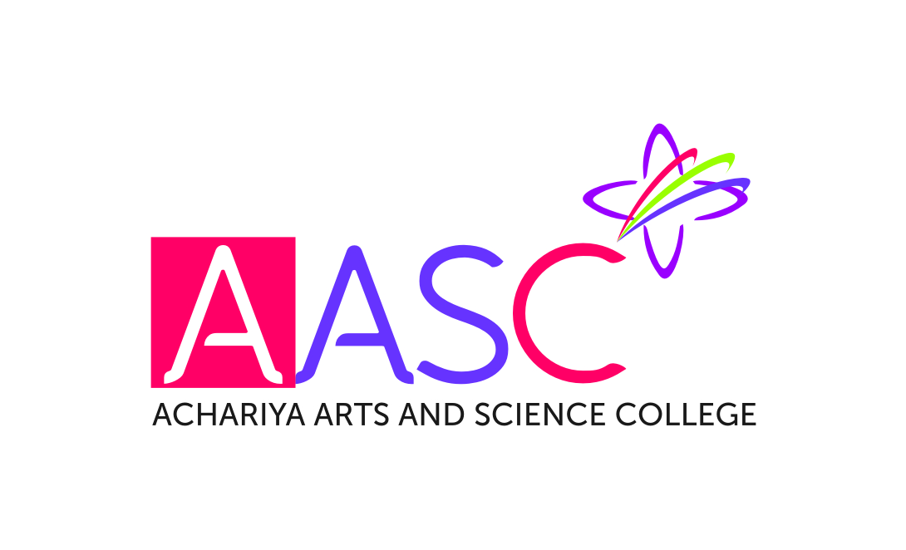
ACHARIYA ARTS AND SCIENCE COLLEGE
(Affiliated to Pondicherry University)
DEPARTMENT OF MATHEMATICS
DEPARTMENT ACTIVITY FOR THE ACADEMIC YEAR 2020-2021

1. Webinar on 06.02.2021

The Department of mathematics Conducted Webinar on the Topic “ Fuzzy Mathematical Techniques in Various Fields” by 06.02.2021 by Dr.K. Sampath kumar on 06.02.2021. Welcome speech addressed Dr.D. Senthil Kumar HOD of Mathematics . Followed by Presidential address by Mr.K.RameshBabu Vice Principal.

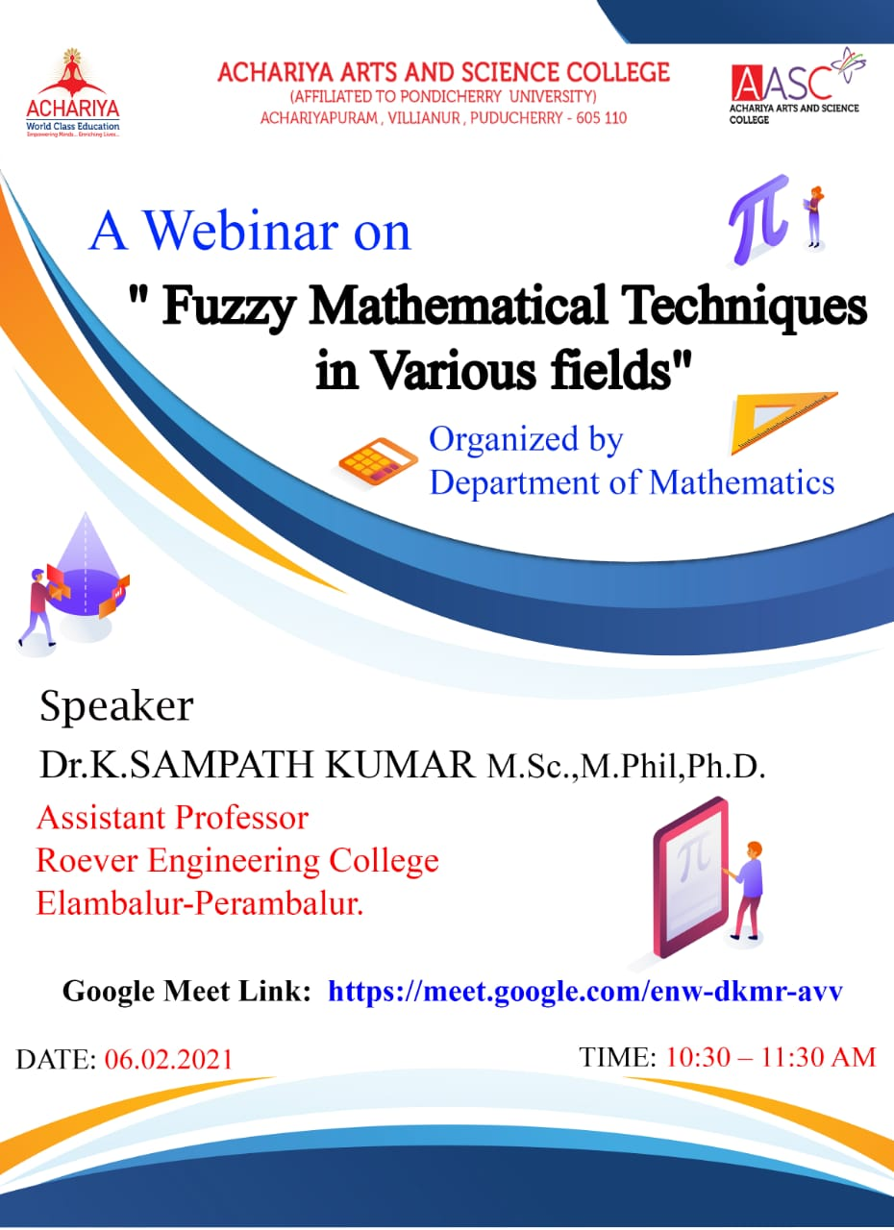

2. Webinar on 21.05.2021
The Department of mathematics Conducted Webinar on the Topic “Teaching Mathematics in the Post Covid Era” by Dr.S. Singaravelu on 21.05.2021. Welcome speech addressed Dr.D. Senthil Kumar HOD of Mathematics . Followed by Presidential address by Mr.K.RameshBabu Vice Principal.

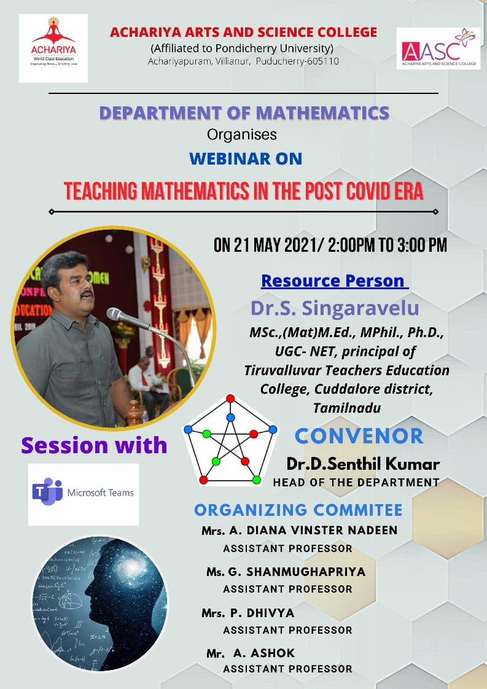
3

